***Contact Management System***

## Introduction

This project has been created to manage the contacts by adding, deleting and updating them.

Project has 4 tier architecture, and consist of following component.

* Database System (MS SQL Server)
* Repository: To deal with database system.
* Web API: Generic interface which talk with client and DB server.
* MVC client.

Client 1  
Java

Web API

DB

MVC Client

Repository

Client 3   
PHP

# Steps to run the CMS project on your local environment.

Copy the **Project folde**r from repository to the installation machine.

## Software required:

1. **Microsoft Visual Studio** (2013 or later version): Installed with .Net Framework 4.5.2 or later.

1. **Sql server 2012** or later.
2. **Sql Server Management Studio**

## Steps to set database:

1. Open **Sql Server Management Studio** andconnect to your **database** server**.**
2. Open new **query** **window** and run the **deployment** script given under main folder(CMS).

\CMS\DB_Scripts\script_Deployment_Contacts.sql

1. This will create a new database, table and will insert one row.
2. In case if it is not created the above DB object, run the rollback script and then again run the deployment script.

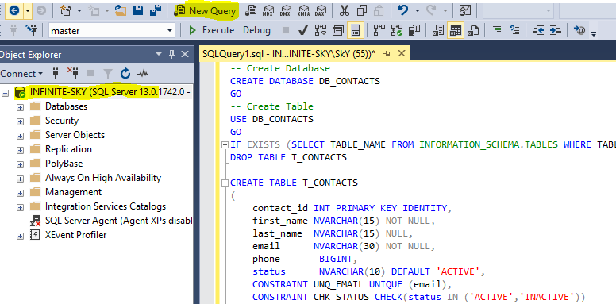

## Steps to set application:

1. Open the main project folder and go to following path

\CMS\ContactManagementSystem\ContactManagement.Repository\App.Config

1. Edit the file ‘**App.Config’** by opening it in notepad.

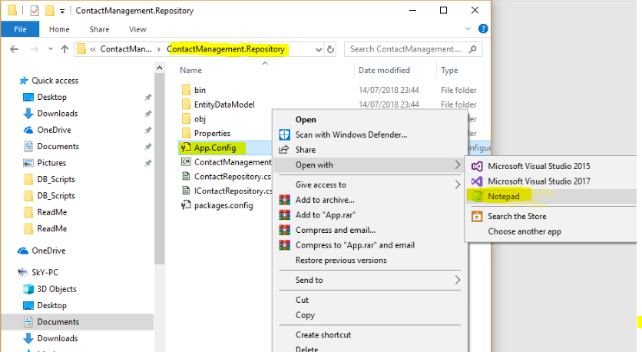

1. Replace the **text** after ‘**data source=’** inside connection string tag (<connectionStrings> </connectionStrings>) with the **Database Server** name. if you running it to your local machine you can try it by placing only ‘**.**’ Or ‘local host’.

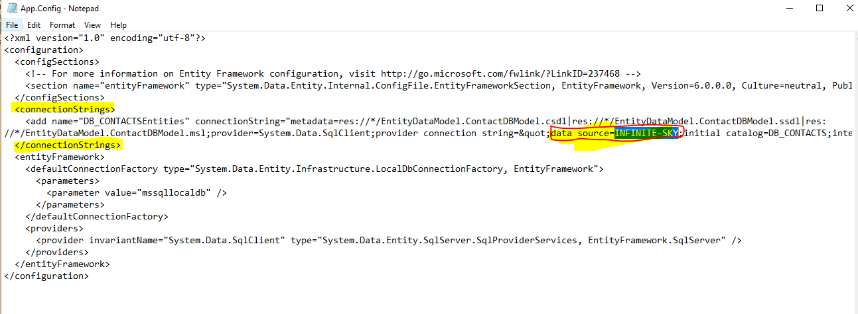

1. Open the main project folder and go to following path:

\CMS\ContactManagementSystem\ContentManagement.API\Web.config

1. Edit the file ‘**Web.config’** by opening it in notepad.
2. 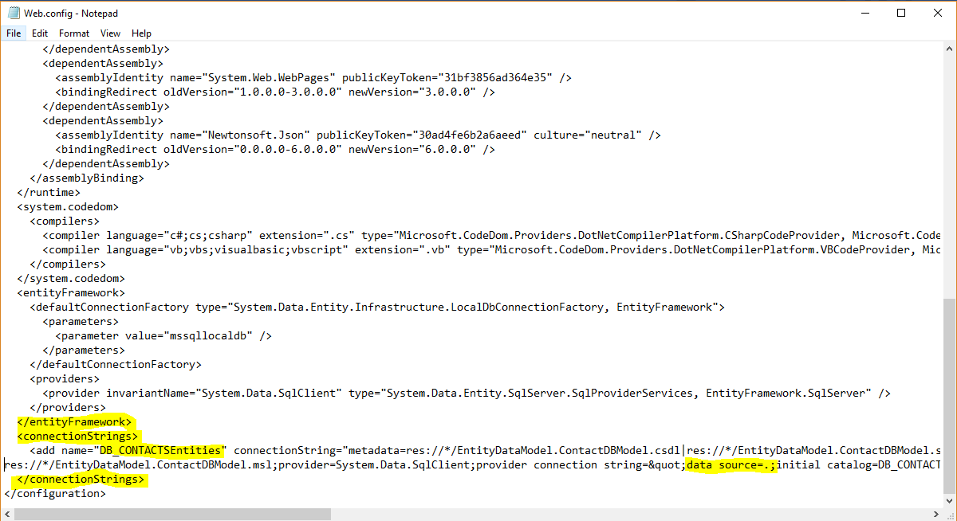Replace the **text** after ‘**data source=’** inside connection string tag (<connectionStrings> </connectionStrings>) with the **Database Server** name. if you running it to your local machine you can try it by placing only ‘**.**’ Or ‘local host’ (Same as above)
3. Now open the main project folder and go to following path:

CMS\ContactManagementSystem\ ContactManagementSystem.sln

1. Double click the solution file (**ContactManagementSystem.sln**) and open it on visual studio.
2. 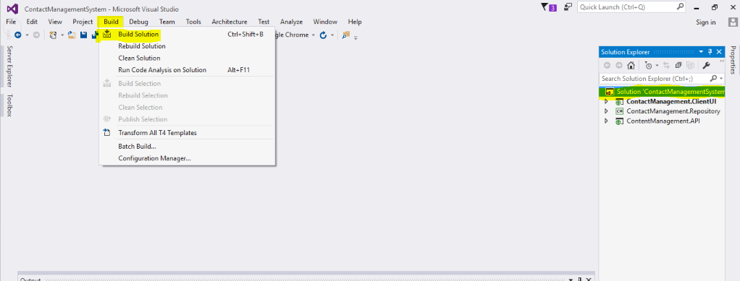Once it opened, select the solution on solution explorer and build the entire solution once.
3. 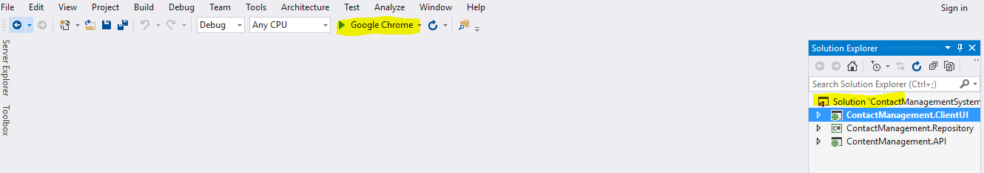Click on start button and run the application.
4. If it is not getting start, right click on project ‘**ContactManagement.ClientUI**’ and set it as start-up project and run again.
5. 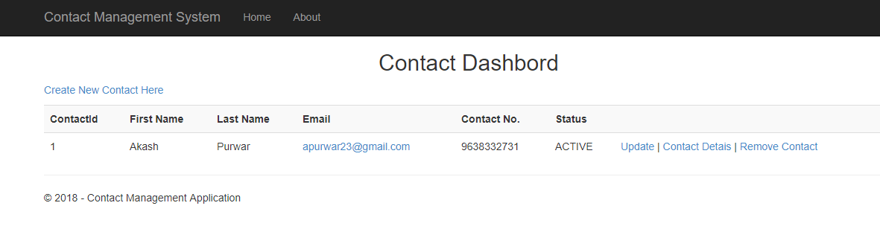 After successfully start application will look like following

